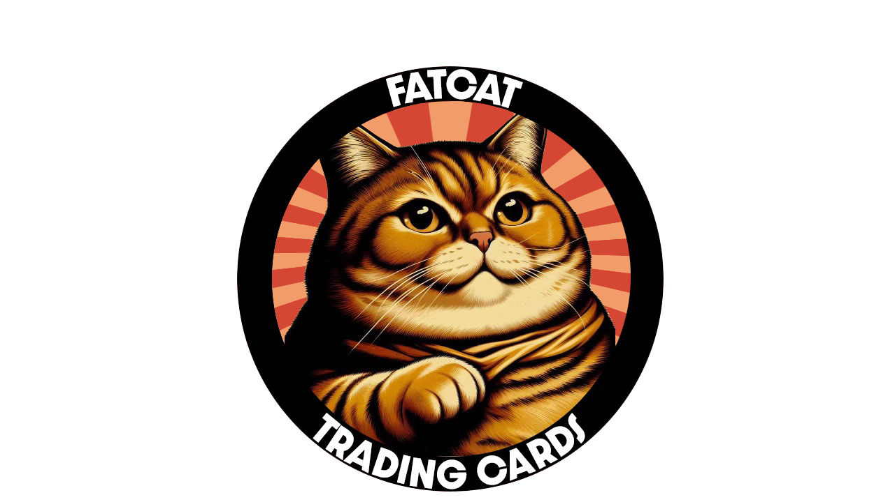

FatCat Wholesale Partnership Application

Thank you for you interest in joining our wholesale partnership program! Please be sure to complete the entire application. If there is a question you aren't sure how to answer, or it isn't applicable, please answer as best you can or leave a note at the bottom explaining why it's not applicable to you.

Name (First & Last):

Location (City & State):

Are you a steamer?

If so, what streaming platforms are you on? (TikTok, whatnot etc)

Do you have a streaming schedule?  
   
 Do you know your average viewership count?  
   
 Total sales in the last 30 days across all sales channels:  
   
 Estimated planned order amount per month (Ex. $2500/month):  
   
 How did you hear about us?  
   
   
Completing this application does not guarantee your acceptance. We do our best to screen all applicants to ensure our partners will do right by our customers. If we have a concern, we may reach out to you for further clarification. Upon completing this application, please email this back to the following:  
  
[support@fatcatcards.net](mailto:support@fatcatcards.net) and title the email “Wholesale Partnership Application”

PLEASE NOTE: The amount you plan to spend each month does not have a sway in the acceptance decision, we look for quality of partners, not how much you sell.